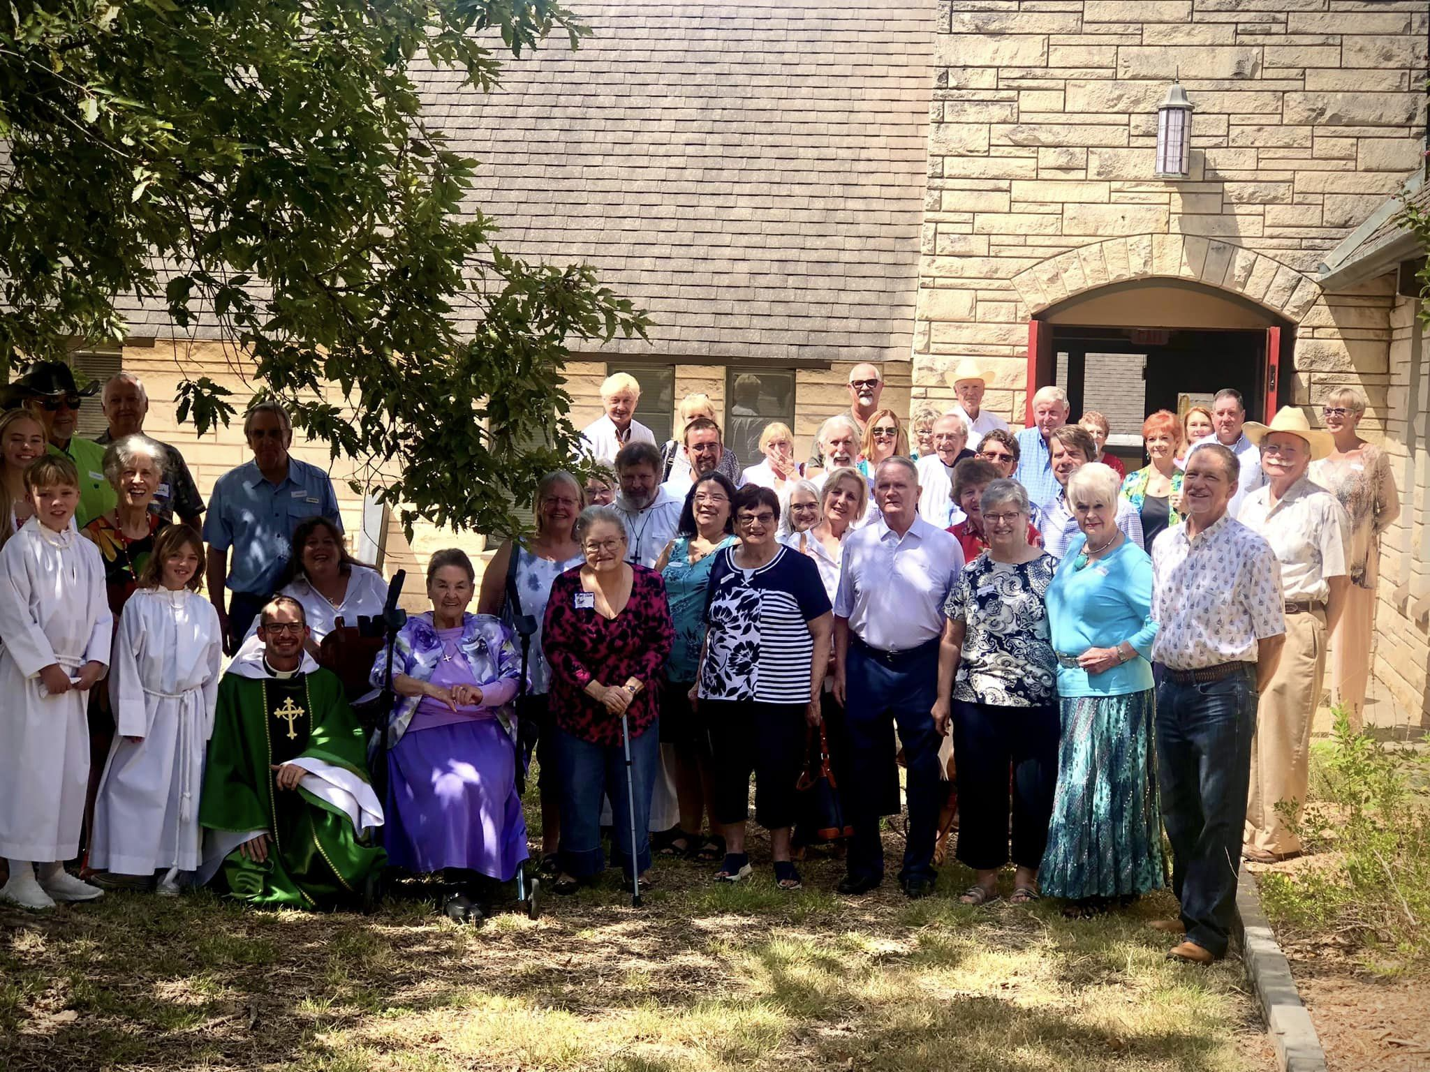

The Spirit
August 2023 Ordinary Time

"At St. Christopher’s we are called to welcome all people and invite them into a relationship with Christ. We believe growing together in Christ through worship, study, fellowship, and service transforms our lives and the lives of others in our parish and community.”
From the Rector
THE REV. ROB HARRIS
When I visited Massachusetts a few years ago with my extended family I was introduced to a more intimate experience of lobsters. I learned how they were harvested, the best environment in which they thrive and also how their shell works as an all-important aspect of their ongoing journey. From time to time, lobsters have to leave their shells in order to grow. They need the shell to protect them from being torn apart, yet when they grow, the old shell must be abandoned. If they did not abandon it, the old shell would soon become their prison--and finally their casket.
The tricky part for the lobster is the brief period of time between when the old shell is discarded and the new one is formed. During that terribly vulnerable period, the transition must be scary to the lobster. Currents gleefully cartwheel them from coral to kelp. Hungry schools of fish are ready to make them a part of their food chain. For a while at least, that old shell must look pretty good.
We are not so different from lobsters. To change and grow, we must sometimes shed our shells--a structure, a framework--we've depended on. Discipleship means being so committed to Christ that when he bids us to follow, we will change, risk, grow, and leave our "shells" behind.
Following up on this metaphor of the Christian life, I am currently reading a wonderful book by Tod Bolinsger, Canoeing the Mountains. It is the tale of the Lewis and Clark Expedition to discover a waterway that would connect the mighty Mississippi River with the Pacific. Their task commissioned by President Thomas Jefferson in 1804, was an all-important one in that it would cause trade to exponential increase, further solidify the unity of the nation, and allow rapid transit to the frontier.
Lewis's journal records that on August 12, 1805, a member of the expedition, Private Hugh McNeal, "exultingly stood with a foot on each side of this little rivulet and thanked his God that he had lived to bestride the mighty and heretofore deemed endless Missouri."
The Missouri at its source looks a lot different than the powerful current that flows into the Mississippi River near St. Louis!
When Lewis found that small trickle of water, the small spring that formed into the mighty Missouri River traversing all the way to the Gulf of Mexico he was elated as I mentioned before. He thought this was the end of his journey. He had discovered the route that would enable the country to flourish. His task was completed. Or so he thought. Lewis slaked his thirst from that small spring and imagined that if his crew could just carry their canoes over the next hill, they would look down upon the river that would connect the Pacific Ocean with the Mississippi and one of the greatest accomplishments of this expanding nation would be realized. They were sorely disappointed. When they reached the crest, they saw not a river but what seemed to be endless mountains stretching into the distance, as far as the eye could see.
One man in the crew declared, “They were the most horrible mountains I had ever seen.”
They had expected to carry the canoes for a little but then be able to cross the continent by boat. But at this moment for Lewis, everything changed. They thought the hardest part was behind them but in fact all they had accomplished so far was but a prelude to what was in front of them. They would have to change plans, go off the chartered course, reframe their entire mission.
The true adventure—the real discovery---was just beginning.
Would they carry the canoe over those mountains hoping that THEIR dream, the way THEY wanted it would come to fruition or dump the canoe and carry only the necessaries along with them as they entered a new journey.
Our 75th Anniversary Celebration reminded me that there is much to treasure in this community’s past. There are many things we must carry with us into the future. These are necessities. Also, as the church is in an emerging culture, where the landscape is constantly changing, we must be willing to leave behind our shells, canoes, or whatever holds us back from flourishing in this time, in this place. As we do this work, I think we might keep in mind the Scripture we find in Matthew 14. This is the account of Jesus walking to the disciples across the crashing waves and his invitation to come to him across the water. A seemingly impossible task! But Peter steps out of the boat and indeed walks toward Jesus over the waves, keeping his eyes on his Lord. It is only when he looks down in fear that he begins to sink. Of course, Jesus is there to pick him back up. Once again Peter’s eyes are on Jesus, his Lord and Master.
May we too keep our eyes on Jesus as our sole support and when the waves begin to churn, shed our shells and drop the canoes for he is our only help and salvation. +
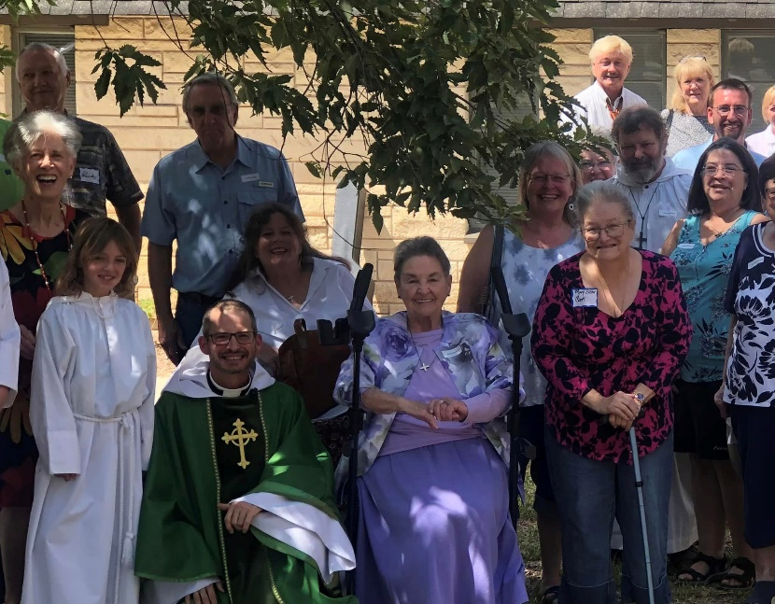
It’s Time to Rally!
On September 10, there will be one service at 10:00 a.m. and we will bring back an old Episcopal tradition of “Rally Day.”
At the beginning of the Fall often Episcopal Churches will hold a day of celebration with opportunities to join is varied ministries in the church, learn more about what is going on and will be going on in the church’s life. +
There will also be a potluck lunch to enjoy.

The call of all Christians is to be involved in the life of their church, utilizing their gifts and talents to the glory of God. Here are some great opportunities to do just that:
- Be a Reader on Sunday mornings.
- Serve the Chalice during Holy Communion.
- Be a Greeter or Usher on Sunday mornings.
- Help with our Youth Group on Wednesday evenings.
- Join our Outreach Committee
- Help with Livestreaming on Sunday mornings.
- Create your own ministry. Come and talk to Father Rob!

Server Schedule
8:30 a.m.
DATE | LECTOR | CHALICE
6 | Bill D.
13 | Terry P. | Terry P.
20 | Bill D.
27 | Terry P. | Terry P.

10:30 a.m.
DATE | LECTOR | CHALICE | USHER
6 | Sandra H. | Bob V. | Parsons
13 | Mary Beth W. | Don W. | Parsons
20 | Milam B. | Margaret V. | Parsons
27 | Carol L. | Tom L. | Parsons

Birthdays
AUGUST
5: Judd Bohannon
John Bohannon
8: Jules Jourde
13: Linda Parsons
14: Scott Rowett
16: Mary Beth Wright
24: Charles Rowett
Anniversaries
AUGUST
6: Judd and Doris Bohannon

Need Prayer?
Contact Katie Bussineau at
(830) 890-2331
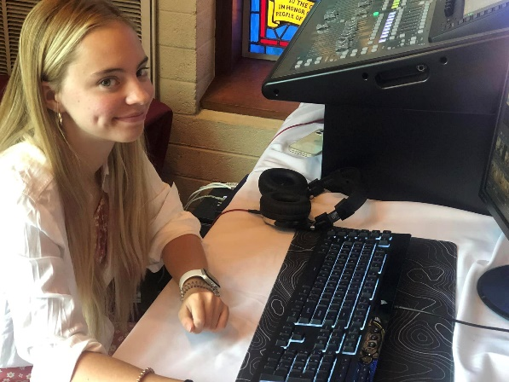
Help with Livestreaming? It’s not hard and we’ll train you. Cause the Good News to extend beyond our walls.

Donate Flowers to the Glory of God and Mission
If you would like to dedicate Altar Flowers in thanksgiving or remembrance for someone add your name to the list in the Narthex, fill out a card and place your check in the offering plate designated “flowers” or drop off cash or a check to the church office. All money collected from the Flower Fund goes straight into our Outreach program to serve the neediest among us.

75th Anniversary Celebration
The celebration of St. Christopher’s ministry in Bandera on Sunday, July 23rd was a rousing success! IT was wonderful to have the parish and extended parish family gather together to celebrate the work God has done in this community for decades as well as celebrate what is to come. Senior Warden, Ann Hevenor, expressed it this way, “I love to come into the sanctuary on those days that I am assigned to get the sanctuary ready for Sunday morning as a member of the Altar Guild. I am alone in the quiet and can feel the peace and love of God that has permeated this place since I was a child. Whether St. Christopher’s has five members or one hundred and fifty, that is what I want visitors and members to feel, the Spirit of God, love, peace, and welcome.
Those gathered enjoyed a delightful lunch and herd many testimonies of what ST. Christopher’s has meant to them over the decades. Jeff Miller, son of Susie Birdsong, shared a memory of his own. He shared the story of how St. Christopher’s saved TMI (TMI: The Episcopal School of Texas, formerly The Texas Military Institute). Miller told the story of how because of a relationship formed between The Reverend Nelson Daunt (then Rector of St. Christopher’s and Chaplain of TMI) and Mr. Albert Alkek formed. Miller described the spiritual nurture Mr. Alkek received from Reverend Daunt and when Mr. Alkek was made aware by Daunt of the terrible financial hardships TMI was experiencing, because of their friendship and Mr. Alkek’s broadening spiritual life, Mr. Alkek donated a sizable amount of money to bail out TMI and set them on the road to success which they now enjoy as one of the best preparatory schools in San Antonio. +
The afternoon gathering was a wonderful time of fellowship, remembrance, and the joy of the Lord. Now on to 100 years of ministry and beyond.
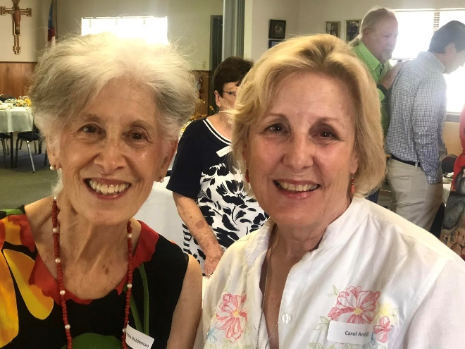
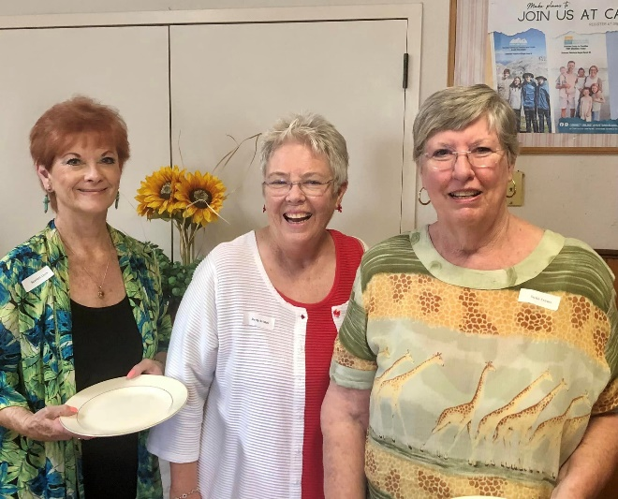
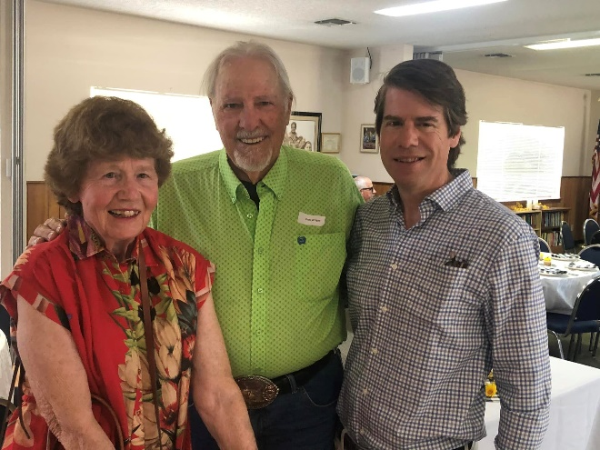

Christian Education
Classes are held on Sundays (unless otherwise noted) in the Parish Hall, beginning at 9:30 a.m.
AUGUST
No CLASSES (Father Rob out of town)

SEPTEMBER
A Study of Cranmer’s Church (A Study of Anglicanism)

OCTOBER
Holy Days, Holy Time, Holy Symbols

NOVEMBER
A Study of The Great Thanksgiving (Holy Eucharist)

DECEMBER
A Study of the Theology of Incarnation

“One cannot truly know the heights and depths of God unless one studies the Word and Ways of God” -Fr. Harris

Men’s Bible Study
Join us each Tuesday at 9:00 a.m. in the Parish Hall for Men’s Bible Study. We invite you to bring your own breakfast as we dive into the word of God and seek out its applications for daily life. +

Youth Group resumes on September 6!
Spread the word.
Dinner, Activities, Study, and Prayer.
All are welcome!

Women’s Study
Beginning on Thursday, September 7, at 11:00 a.m. Father Rob invites all women to join him for the renewal of this important program for the women of our parish. The first study will follow Presiding Bishop Michael Curry’s program, The Way of Love. The study will include video presentations, study of The Way of Love principles, and lively discussion. Join us and begin the revitalization of Women’s Ministry at St. Christopher’s! +

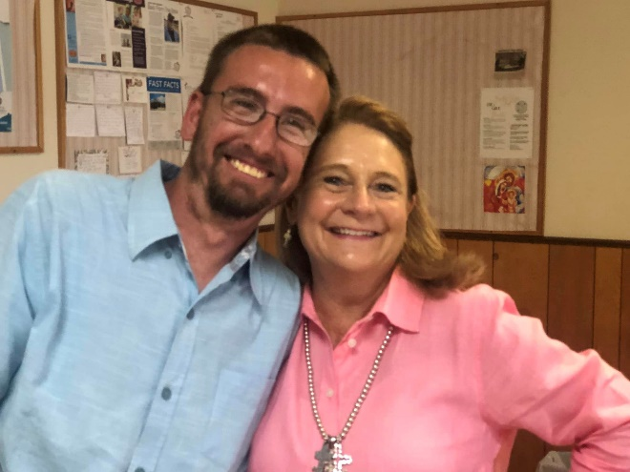
Outreach
The Outreach Committee met on Tuesday, July 25, in the Parish Hall. Members present were: Mike Mulherin (chair), Bunny Bond (Clerk), Carol Antill, Katie Bussineau, and Father Rob Harris (ex-officio).
The committee discussed the need to keep parishioners aware of the First Sunday In-gathering of food for Held Hand, further work was undertaken for the new Bereavement Committee headed by Carol Antill, and the disbursement of money for a camp scholarship for Caroline Harris. A discussion regarding the release of Federal COVID funds being allocated to various non-profits and NGO’s was also undertaken.

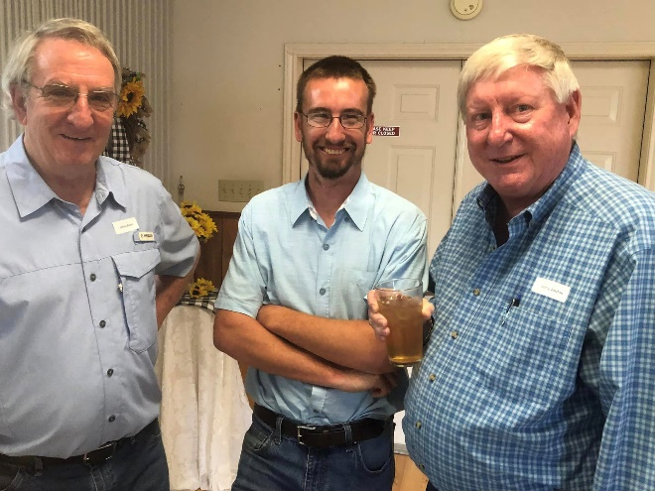

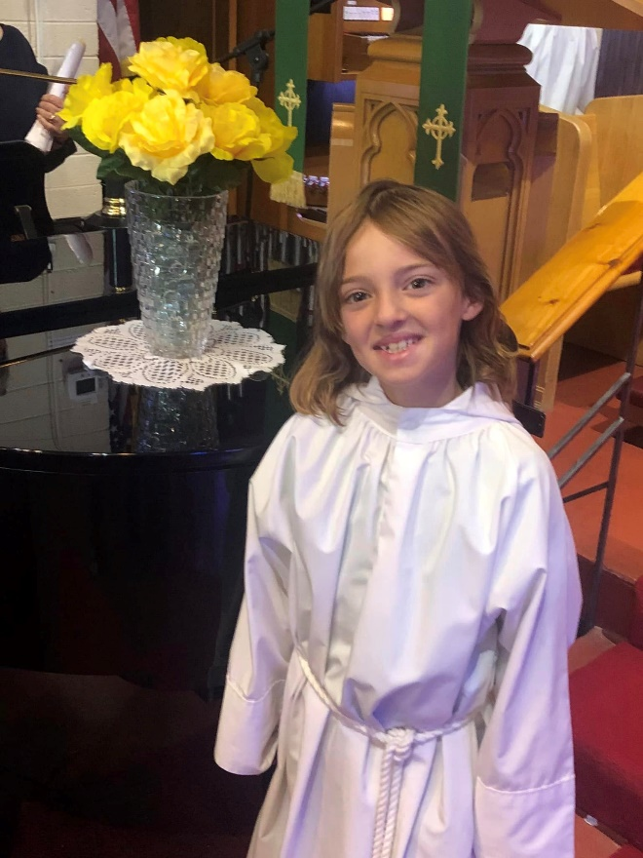
Church studies continue to report that when you invite someone to church there is a 98% chance they will come. Studies show that advertising and church “gimmicks” only have a 2% return. Be a part of the continuing legacy of those who in the past have invited others into the life of this place.
-Invite, Welcome, Connect

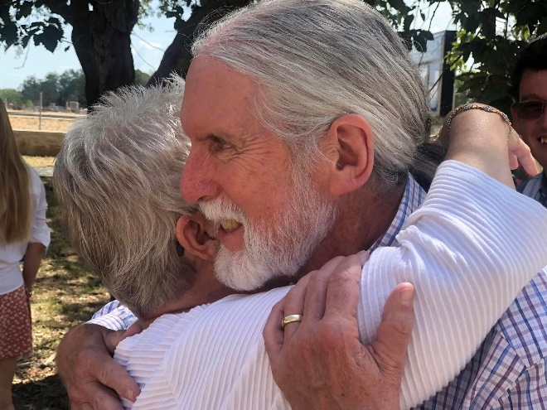

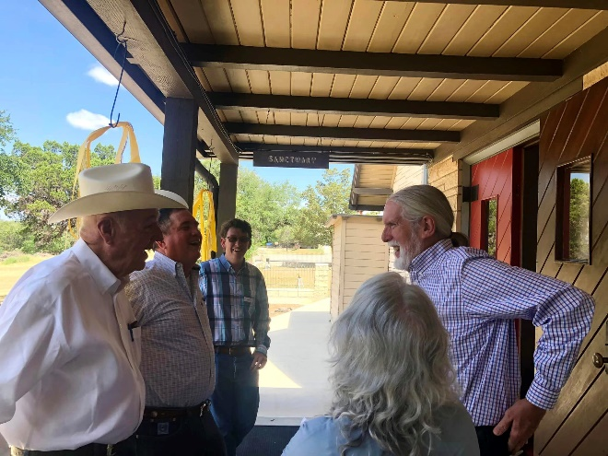
75th Anniversary Celebration!
Around the Diocese
The Rt. Rev. Dr. David G. Read Ordained and Consecrated Bishop Coadjutor of West Texas
The Rt. Rev. Dr. David G. Read was ordained and consecrated Bishop Coadjutor of the Diocese of West Texas on Saturday, July 8 in All Saints Chapel at TMI Episcopal, San Antonio. Bishop Read will work alongside the Rt. Rev. David M. Reed, Bishop of West Texas, until his retirement on January 1, 2024.
The Rt. Rev. W. Michie Klusmeyer, Canon to the Presiding Bishop for Ministry within The Episcopal Church, was the chief consecrator and six bishops joined him as co-consecrators, including the Rt. Rev. David M. Reed, D.D., Bishop of West Texas; the Rt. Rev. Rayford B. High, Jr., D.D., Assistant Bishop of West Texas; the Rt. Rev. James E. Folts, Eighth Bishop of West Texas, retired; the Rt. Rev. Dr. Jonathan H. Folts, Bishop of South Dakota; the Rt. Rev. Kathryn M. Ryan, Bishop Suffragan of Texas; and the Rev. Susan J. Briner, Bishop of the Southwestern Texas Synod of the Evangelical Lutheran Church in America.
A total of fourteen bishops were in attendance for the traditional laying-on of hands. 700 in-person attendees participated in the joyful service, with more than 100 people joining the livestream concurrently from across the diocese and the country.
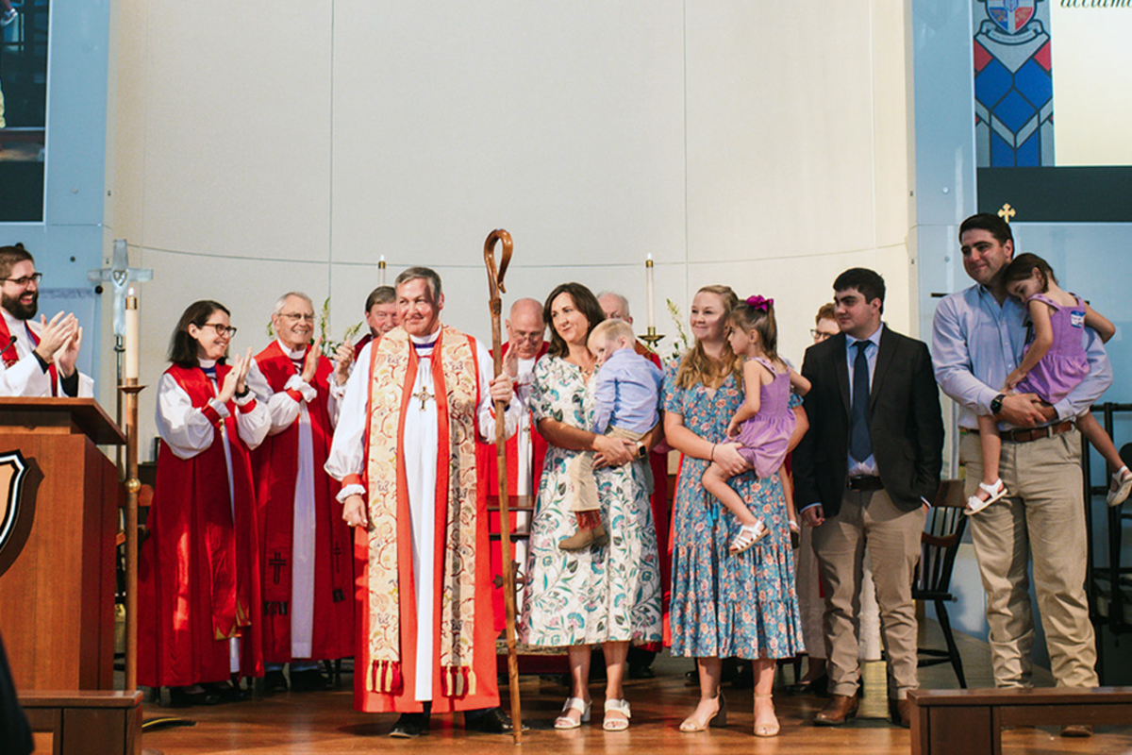
Bishop Reed, current Diocesan Bishop, preached and began his sermon by thanking everyone who had assembled, including Chief Consecrator Bishop Klusmeyer, and sending greetings and prayers for continued recovery to Presiding Bishop Michael Curry. (continued on next page)
Our new Bishop Coadjutor, The Right Reverend David G. Reed and family are welcomed by the people of the Diocese of West Texas in a standing room only celebration.
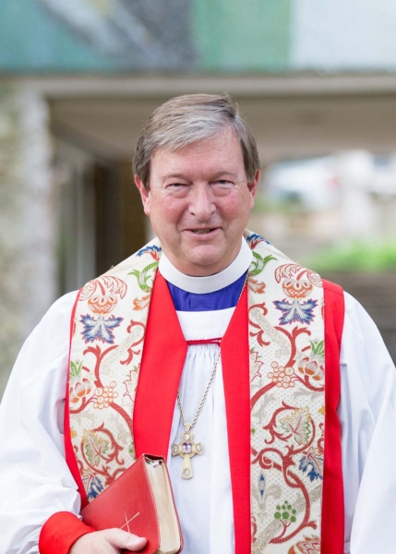
Inspired by his own time as a bishop he said, “Of all the good gifts that David is getting today we the Church – lay and ordained – end up being God's best gift to him. You might look around here for a second, David; go ahead and take a peek behind you. This is what you get – our love, our support, our trust, our forgiveness, our prayers, our showing up. These are all gifts that he will need us to offer now, and in the years to come.”
“Some of [David’s] best moments, the holiest times, will be when he finds himself in the midst, when he finds himself among the clergy and people side by side in the life and work that our Lord Jesus gives us," Bishop Reed continued, reflecting on the Gospel reading chosen for the service, Luke 10:1-12. Reed has served as the tenth diocesan bishop since 2017, following his time as its bishop suffragan beginning in 2006.
Service music was offered by members of St. Boniface, Comfort; St. Francis’, San Antonio; St. Helena’s, Boerne; St. Nicholas, Bulverde; and St. Peter’s, Kerrville choirs directed by Lynne Lowry as well as the St. Helena’s Singers, a youth choir, and a brass quartet, led by Rod Leonard from TMI Episcopal. Hymns and congregational singing were led by Dr. Susan Matteson, organist, and Bryce Boddie, guitarist, both from St. Helena’s, Boerne.
Bishop David M. Reed, current Bishop Diocesan
The service incorporated Spanish throughout, including the First Lesson reading from Isaiah, the Gospel Reading from Luke, which was read in English and Spanish, and the final Communion hymn, Alabaré a Mi Señor, which perfectly encapsulated the service: “Todos unidos alegres cantamos, 'Glorias y alabanzas al Señor. Gloria al Padre, gloria al Hijo, y gloria al Espiritu de amor.'” [All sang together joyfully, 'Glory and praise to the Lord. Glory to the Father, glory to the Son, and glory to the Spirit of Love.']
The traditional bishop gifts presented during the service included vestments given by the Clergy of the Diocese; a pectoral cross given by family, friends, and the West Texas congregations where Bishop Read has served; a ring given by his parents, William and Doris Read, and brother, Kelly Read; a crozier given by Robert and Lorraine Cheeseman, parents of Jaqui Read, his wife; and a Bible given by Bishop Klusmeyer on behalf of the Most Reverend Michael Curry.
The Episcopal Diocese of West Texas spans sixty counties and 69,000 square miles in southern Texas. Its 87 congregations serve approximately 20,000 parishioners.
An Investiture Service of Choral Evensong will be held on December 1, 2023 at St. Mark’s, San Antonio. During the service, the Bishop Coadjutor will ceremonially receive the diocesan crozier from the outgoing Bishop Diocesan, as a sign of the transfer of authority. All are welcome to attend.
A video recording and the consecration service bulletin are available on the Diocese of West Texas website, at dwtx.org/consecration, as well as its social media channels. +
Bishop David G. Reed, Bishop Coadjutor
Pathways to Hope: August 25 - 26
Pathways to Hope is a free, in-person conference bringing together mental health professionals, social workers, educators, the judicial system, law enforcement, faith community leaders, caregivers, and individuals living with a diagnosis to help improve the mental health care system.
Monthly Caregiver Support Group: August 9
Are you caring for a loved one in a time of illness or crisis? Being with others who are, or who have been, in a similar situation can be comforting and helpful. The Caregiver Support Group meets on the second Wednesday of each month from 1:30 p.m. to 2:30 p.m. in the Mission Room of the Bishop Jones Center and is open to all.
Camp Capers Mother/Daughter Retreat: September 8 - 10
Mothers, Daughters, Grandmothers, friends, and mentors of all ages will strengthen their unique bond while participating in fun and faith-centered activities such as swimming, high ropes, kayaking, gardening, arts and crafts, hiking, worship services, Bible lessons, and so much more.

Join the Diocese of West Texas in giving thanks for the life and service of Dr. Artemisia Bowden next month on August 18. Dr. Bowden was called to lead and develop a local school for women by the Second Bishop of West Texas. Under decades of her faithful leadership it grew and developed into today's St. Philip's College, a strong part of the Alamo Colleges District in San Antonio. The Episcopal Church's 78th General Convention added Bowden to its liturgical calendar.

The Plaza de Paz Respite Center and diocesan Immigration & Refugee Ministries has issued an urgent request for shelf-stable food items, new clothes, and volunteers to help individuals and families en route to sponsors and family members throughout the country. Needed items may be purchased through their Amazon List and Walmart List. Contact Flor Saldivar, Director of Immigration Ministries, at flor.saldivar@dwtx.org to join in.
Save the date for the diocesan Daughters of the King® 2023 Fall Assembly:
September 15 - 16, 2023 at St. Alban's, Harlingen.
Registration will open on August 1.
Prayers Requested for the Discernment of our Next Presiding Bishop
The members of The Episcopal Church Joint Nominating Committee for the Election of the Presiding Bishop invite Episcopalians to join them in prayer as they continue their discernment work leading to the election of the 28th presiding bishop next June.
The members offered this prayer:
Almighty God, source of all wisdom and understanding: Look graciously on your church, and so guide the hearts and minds of those who will choose our next presiding bishop, that we may receive a faithful pastor who will care for all of your people, equip us for our ministries, and proclaim your word to us and to the world, through Jesus Christ our Lord. Amen.
“Our meetings, whether online or in person, have been grounded in prayer and worship,” said the Rev. Deborah Jackson, committee member and chaplain. “We hope that Episcopalians will join us in praying for the Holy Spirit’s guidance.”
Episcopal Diocese of Alaska Bishop Mark Lattime said, “We also hope that congregations will include this prayer in the Prayers of the People the Sundays between now and when the election takes place in Louisville, Kentucky, next June 26.”
The JCNPB also reminds members of the church that they have until Saturday, July 15, to submit the name of a bishop whom, after prayerful consideration, they think God is calling and has equipped to serve as the 28th presiding bishop.
Bishops who discern a call to enter the nomination process must submit their applications by Aug. 15.
The committee will spend the next several months discerning which bishops to nominate to stand for election at the 81st General Convention, scheduled for June 23-28, 2024, in Louisville, Kentucky. It will announce its slate of nominees in the spring of 2024.
Then there will be a set period during which any deputy to the 81st convention or bishop must submit to the committee the names of other bishops they intend to nominate from the floor at convention. Canon I.2.1(d) requires the committee to vet any such nominees with the same process used for its nominees. The names of any such additional nominees will be announced in early June 2024.
The committee is charged with nominating at least three bishops.
The committee began working together in the fall of 2021.

St. Christopher’s Episcopal Church
395 Highway 173 North
P.O. Box 314
Bandera, Texas 78003
Office: 830-796-4387

The Episcopal Diocese of West Texas
The Right Reverend David Reed, Bishop Diocesan
The Right Reverend Rayford High, Bishop Suffragan
The Right Reverend David Reed, Bishop Coadjutor

Staff
The Reverend Rob Harris, Rector
rob@stchrisbandera.org
Ms. Amanda Johnson, Parish Administrator
amanda@stchrisbandera.org
Mrs. Deborah Jonas, Office Manager
office@stchrisbandera.org
Mr. Bill Davidson, Music Director
bill@stchrisbandera.org

Vestry
Mrs. Ann Hevenor, Sr. Warden, Mr. Milam Boyle, Jr. Warden,
Mrs. Mary Beth Wright, Clerk
Mr. Mike Mulherin, Dr. Charles Rowett, Mrs. Julie Allen, Mr. Jimmie Jordan

